EXPERIMENT 2

NAME: ARUNPRANESH ES ROLL NO: 240701051
Design a UI where users recall visual elements (e.g., icons or text chunks). Evaluate the effect of chunking on user memory.

FOOD ORDERING APP – MENU MEMORY TASK
FRAME 1: INSTRUCTION PAGE

Chunking Analysis of the Instruction Page
Chunking is used to break down instructions into simple, clear steps, helping users understand the task quickly.

Clear and Sequential Numbering
  - Instructions are divided into 13 simple steps.
  - Each step explains one action at a time, reducing confusion.

Logical Grouping of Information
  - Viewing Phase : User is informed about menu observation.
  - Memorization Tip : Encourages grouping food items by category.
  - Recall Phase : Explains how users will select remembered items.
  - Evaluation : Accuracy matters more than speed.

Visual Hierarchy and Design Elements
  - Bold heading “MENU MEMORY TASK” grabs attention.
  - Bullet points and spacing improve readability.
  - Highlighted “START ” button guides the next action.
  - Food-themed illustrations add engagement.

Time Constraint Reinforcement
  - Clearly states “You will have 10 seconds to view the menu.”
  - Prepares users mentally for focused observation.

Simplicity and Clarity
  - Short sentences and active voice.
  - No technical or complex terms used.
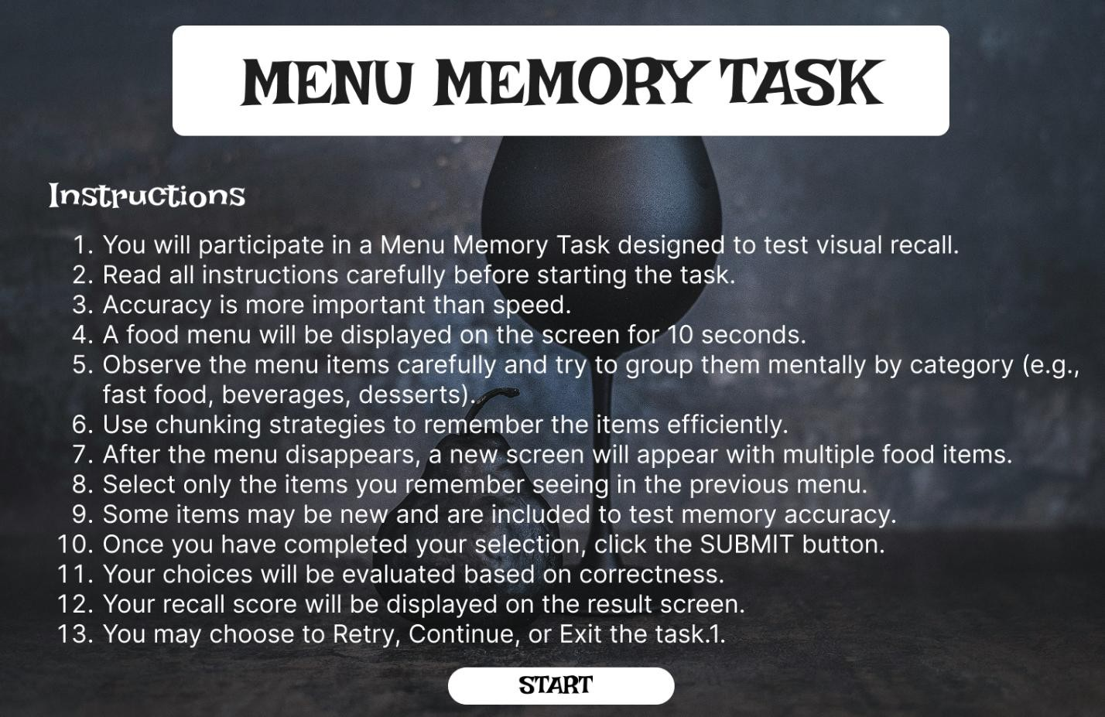

FRAME 2: CHUNKING PHASE (MENU VIEW)

Analysis of the Menu Observation Screen
- Purpose of the Screen
  - This is the visual memory encoding phase.
  - Users observe a food menu and apply chunking strategies.

Key UI Components
  - Countdown Timer (Top Right – “00:10”)
  - Category Sections
  - Food Cards Grid
Encourages chunking by:
  - Food type
  - Color similarity
  - Familiar combinations

How the Chunking Phase Works
  - Users scan categories instead of individual items.
  - Items are mentally grouped by type.
  - Time limit forces efficient memory strategies.

Cognitive & UX Benefits
  - Reduces cognitive load.
  - Improves recall through category grouping.
  - Enhances pattern recognition.

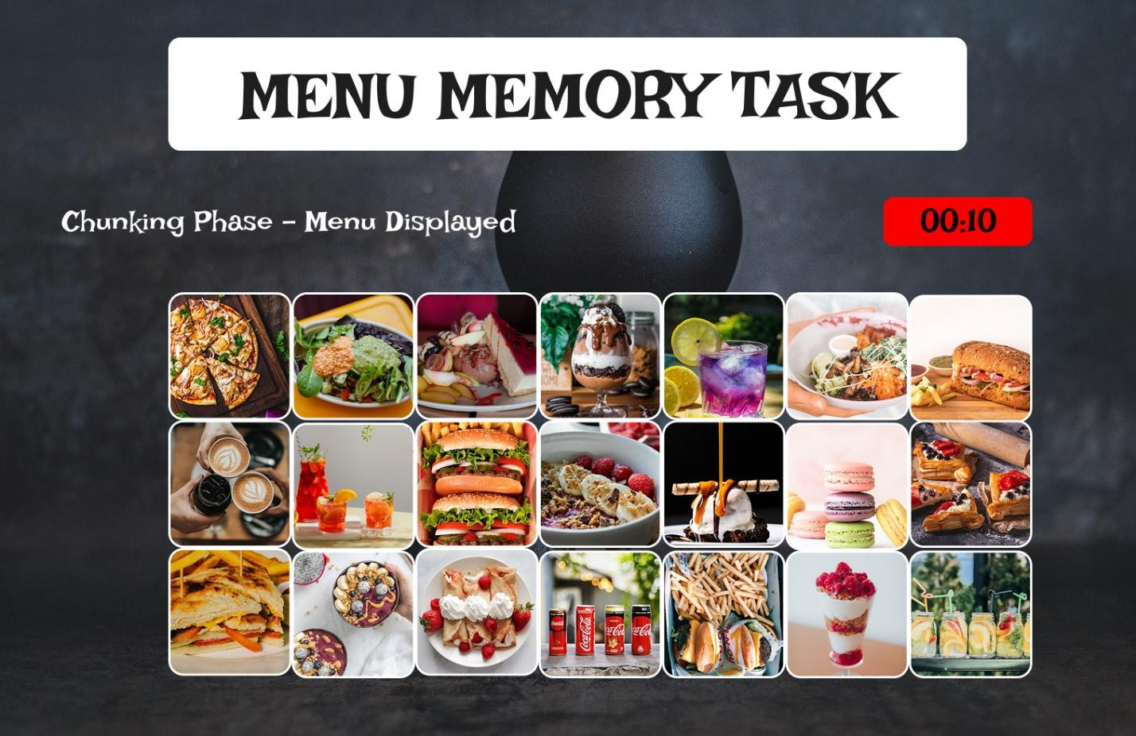

FRAME 3: RECALL PHASE (SELECTION)

Analysis of the Food Selection Screen
- Purpose of the Screen
  - Tests how well users remember menu items.
  - Measures effectiveness of chunking.

Key UI Components
  - Title & Instructions
  - Food Options Grid Mix of:
  - Previously shown items
  - New distractor items

  - Users select remembered items using checkboxes.
  - SUBMIT ORDER Button

How the Recall Phase Works
  - User recalls items from the menu view.
  - Selects remembered items.
  - Distractors test false memory.

Cognitive & UX Benefits
  - Tests short-term memory accuracy.
  - Evaluates real vs false recall.
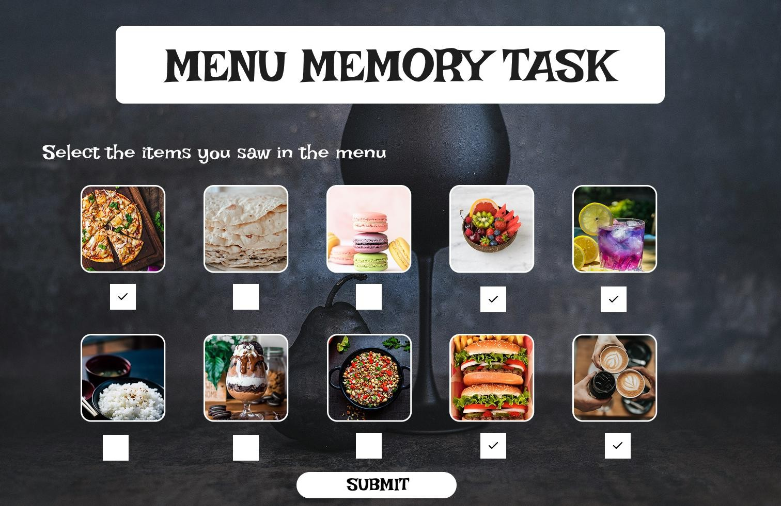
  - Simple interaction improves usability.

FRAME 4: RESULT PAGE

Analysis of the Score & Feedback Screen
- Purpose of the Screen
  - Displays recall performance.

Key UI Components
  - Score Display
“YOUR MENU MEMORY SCORE: 4/5”
  - Large font for clarity.
  - Action Buttons
- RETRY MENU
- CONTINUE ORDERING
- EXIT APP

How This Phase Works
  - System compares selected items with original menu.
  - Score is calculated and displayed.
  - User chooses next action.

Cognitive & UX Benefits
  - User control enhances experience.
  - Gamification reduces stress.

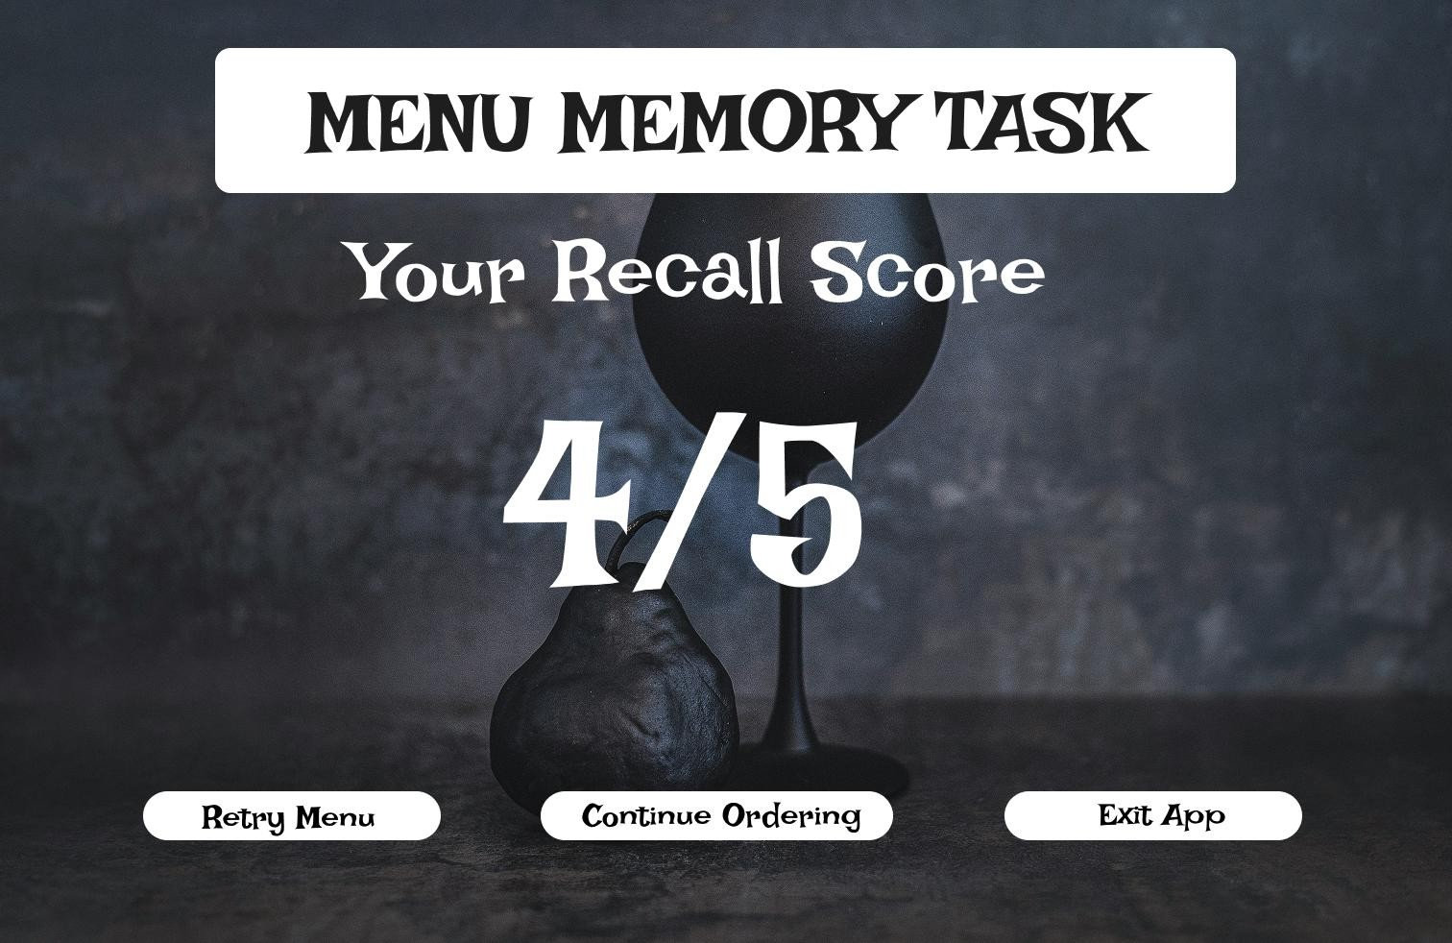

PROTOTYPE LINK:
https://www.figma.com/design/LppNZR4dqlHQZi0tDDa3yF/UID-EXP-2?node-id=0-1&t=9iYue79WZ57qljap-1

